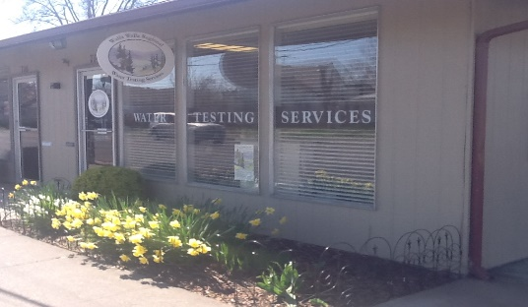
FEES
Bacteria $40.00 GAP $55.00
Nitrate $40.00 GLOBAL GAP $55.00
*A double fee will be charged for any sample received after normal acceptance hours or testing times.
Special Note
All samples must be received by the laboratory within 24 hours of collection. If you collect a sample the day before, please keep the sample refrigerated (DO NOT FREEZE) and bring water samples to the laboratory before 11:30 AM the following morning.

PLEASE CALL AHEAD FOR GAP/GLOBAL GAPS
Monday or Tuesday is preferred.

If Sample is for GAP/or Global Gap please mark the water sample and form accordingly.
Nitrate Sample Collection

1. Locate sample tap after treatment-if any. Preferably, samples should be taken from an inside tap (e.g. kitchen).
2. Remove any attachments or devices from the faucet, along with the rubber gasket if present.
3. Run the cold water for a few minutes, until water reaches constant temperature.
4. Fill the bottle to the shoulder of the bottle, replace cap tightly.
5. Please refrigerate sample and keep cool during transport. DO NOT FREEZE SAMPLE.
6. Fill out laboratory request form completely.

If you need assistance or have any questions, please call our office at: 509-526-9287
Bacteriological Sample Collection
1. Locate sample tap. Samples should be taken from an inside tap (e.g. kitchen).
2. The screen or aerator device should be removed from the faucet.
3. Flame the faucet opening (metal faucets only) with a lighter.
4. Run the cold water for 10-15 minutes at a steady stream, until water is a constant temperature. Slow flow to a pencil stream.
5. Remove the sterile seal from the bottle. With care not to contaminate lid or bottle, remove the cap and fill the bottle between the 100ML and the shoulder of the bottle. Do not overfill NOTE: Do not rinse out this bottle, the white powder inside the bottle belongs there.
6. Keep sample cold during transport to the lab.
7. Fill out the top half of the laboratory slip completely.
Dates/Times Samples Accepted

Samples should be taken and brought in immediately if possible.

Monday-Wednesday 8:00 AM — 11:30 AM and 1-5 PM
(Closed Noon-1PM for Lunch.)
Thursday 8:00 AM — 11:30 AM Coliform Bacteria Samples ONLY.

NO NITRATE SAMPLES WILL BE ACCEPTED AFTER WEDNESDAY.
No water samples accepted on Thursday afternoons or Fridays except by special permission from this Lab.*

